# Initial stages of planning

Researched material design by google.

Google has always surprised me with how good their design looks, it is very simple, clean and gets straight to the point. I decided to try to incorporate what google does into my own website because I felt that material design often keeps your attention better without too much distractions and there isn’t too much clutter of information on the screen to overwhelm you when you are reading through the site.

Planning process

I spent most of the time planning how I would build the website due to not having that much experience with building one from scratch. The 8 weeks were mostly just re-reading of the textbook and seeing what information might be interesting enough to create a website on. After reading through the multimedia section, I decided to do compression techniques.

# Resources for project management

I only used a Gantt chart and some illustrations made by me for project management, the reason why I used a Gantt chart was to keep track of what to do next and what I haven’t completed. The illustrations were used when I was building the site to make sure it turns out similar to what was planned

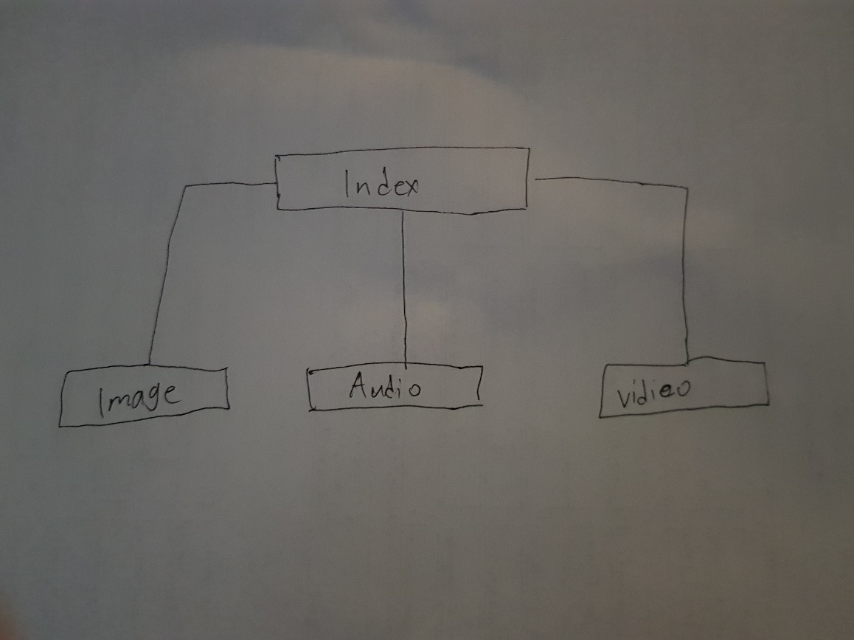

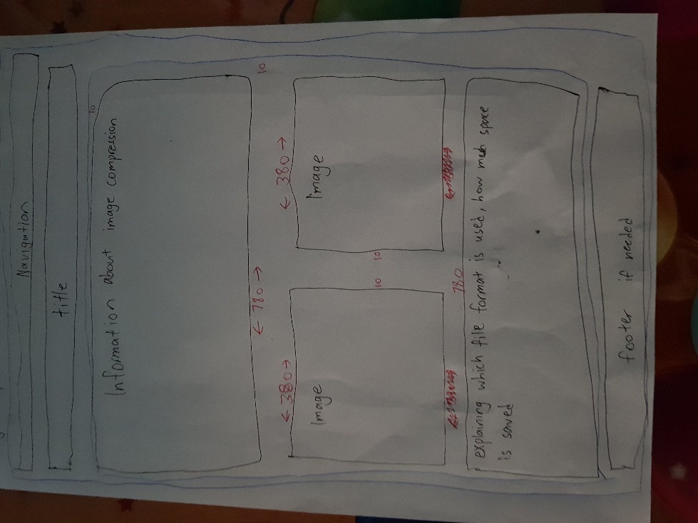

# Resources used for project

I used images and a video and did not use audio because I was unable to get audacity to work on my computer, but audio is incorporated into the video. I mostly decided to use images because they were enough to give some extra information about what was being discussed on the page. The video that is used was to demonstrate quality is not hindered that much with compression. However, I was unable to upload any raw video files because html5 does not support any of them so only the compressed versions were uploaded.

# Feasibility study

The aim of this project is achievable without any extreme requirements, website creation is generally not overly complicated and the main resource that needs to be spent efficiently is time. The project did not require a large sum of money, so it was economically feasible, all information required for the task can be found online for free, however there were some technical constraints. HTML no longer supports uncompressed file formats, so it created a problem that I could not solve. There was adequate time given to complete the assessment, so scheduling would be a lot easier. The operation of the site will be able to assist other students in studying, it should also be more interesting for students from the addition of other media types.

# Social and ethical

The project should not affect any social and ethical problems, there are no content that may be inappropriate. However, the website only has English, so any none English speakers won’t be able to understand the information. While creating the website people with slow internet was taken into consideration, the images have alt tags that has text explain what the image should be. The only content that wasn’t created by me on the website were photos taken from google images.